**LEBANESE AMERICAN UNIVERSITY**

**USAID – HIGHER EDUCATION SCHOLARSHIP PROGRAM**

**HES - Volunteering Program Verification Form**

This form is to be used to document volunteering hours. If a student volunteers for multiple organizations, a separate form must be used for each organization. **This form must be turned in by the 28th of each month, the latest.**

I certify that the scholar Adam Ali Abbas completed a total of 20 hours of service at InnovaThrive.

The hours were completed hours as per the below:

Hours # 5 (date) _4/11 – 8/11_ (initials of supervisor) __A.K.___

Hours # 5 (date) _11/11 – 15/11_ (initials of supervisor) __A.K.___

Hours # 5 date) _18/11 – 22/11 (initials of supervisor) __A.K.___

Hours # 5 date) _25/11 - 29/11 (initials of supervisor) __A.K.___

Brief description of the activities the scholar performed or participated in:

as a moderator on academic research i made an overview and update Digital Learning Platforms: Their Effectiveness and Drawbacks research

Written feedback about the scholar’s performance:

Adam’s role as a moderator on academic research highlights his leadership and subject expertise. His updates and analysis of digital learning platforms demonstrate his ability to evaluate their effectiveness and drawbacks comprehensively, showcasing his critical thinking and organizational skills.

Please rate the overall performance of the scholar at your organization:

|  |  |  |  |
| --- | --- | --- | --- |
|  | Mastery (5) | Proficient (3) | Emerging (1) |
| **Problem solver** | X |  |  |
| **Engaged & Committed** | X |  |  |
| **Open-minded & multicultural** | X |  |  |

Signature

& stamp

__________________________

_

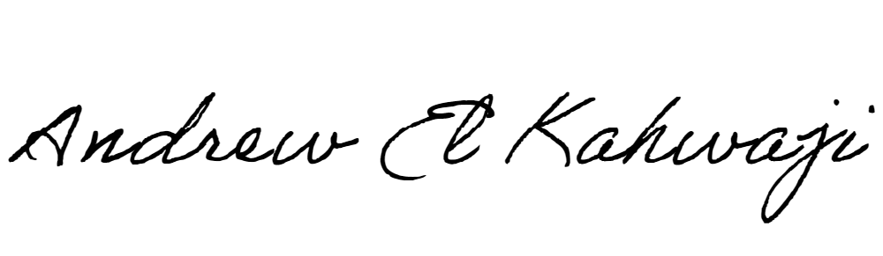

Printed Name _Andrew El Kahwaji_

Date __26/11/2024___

Email __andrew.lifesculptor.coo@gmail.com __

Phone __+961 71 914 378__

**LEBANESE AMERICAN UNIVERSITY**

**USAID – HIGHER EDUCATION SCHOLARSHIP PROGRAM**

